s
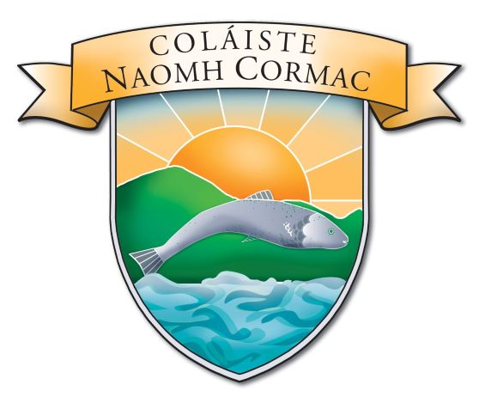

B.OM. AGREED REPORT FROM 12 MARCH 2025
- A presentation from the Director of Schools Linda Tynan to the Board of Management
- Elaine Dermody was welcomed as community representative to the BOM
- Minutes from previous meeting of the 21ST Jan 2025 adopted
- Agenda for the meeting of the 12 March 2025 was accepted
CORRESPONDENCE
- Dept. email regarding school closure 24.01.25
- Letter of thanks for musical sponsorship sent by the Principal
- HSE Data Sharing
- Offaly County Council Arts Grant
- Letter from the Minister of Education regarding School Books
PRINCIPAL’S REPORT
School Management
- School closure 24.01.25 / Musical rescheduled to Sunday 26.01.25
- Mock Exams Reports issued 12.03.25
- 2nd and TY PT meeting 6.02.25
- 3rd and 6th PT Meeting 13.03.25
- Pathfinder update
Management of Resources
- Staff CPD list
- Evenings classes ,YOGA and Airfryer course commenced 24 Feb 2025
- County Athletics use of school Saturday 18th February 2025
- Cairns Rig – Tuesday 18th March – 20 March and evening use by the KDA
- Recipe Cook Book expected publish May 2025
Teaching and Learning
- My Future Quesy 30 Jan 2025
- Mock Exams and Assessment week 6 Feb
- 2nd Year Retreat 26 Feb
- Physics Trip 10 March
- Farmers Journal Article
- RCSI Online Course

School Events
- LOETB LEGO League Winners
- 27 Feb Badminton Leinster Final
- 28 Feb – Visit to Student Council by TD Tony Mc Cormack
- Leinster Final Hurling win over Rathdowney
- 11March Cethan Leahy visit to Book Club
- TY Speaker on Fraud
Student Council Report
- Visit by Tony Mc Cormack
- Biscuits and Bingo 13.03.25
- Agenda and Minutes posted on Student Council Notice Board

SSE – Wellbeing Strand Report
- SSE Staff meeting 5 March Evaluation
- Tus Maith
- Lunchtime events – Basketball and Football Blitz added

